SQL Assignment

Objective
Apply the SQL concepts learned during the session to clean, transform, and query real-world style data using basic SQL operations like filtering, joins, aggregations, and case transformations.

Task Description

Importing Database Classic Models
ClassicModels is a MYSQL sample database which can be downloaded freely from the
internet or your lab instructor will provide you .sql dump database

Procedure to Import database from .sql file

Login to your mysql server in command prompt
C:\.........../bin> mysql –u root –p;
mysql>source sampledatabase.sql;

If the .sql file is in other location than the mysql/bin directory then you have to
give
full path of the file as shown below:
mysql> source F:/db/sampledatabase.sql;

About MySQL Sample Database: Classic Model
The Classic Models database is a retailer of scale models of classic cars. The sample
database contains typical business data such as customers, products, sale orders, sale
order line items, etc.

Sample Database Schema
The sample database schema consists of several tables as below:
Customers: Stores customers's data
Products: Stores a list of scale model cars.
ProductLines: Stores a list of product line categories.
Orders: Stores orders placed by customers.
OrderDetails: Stores order line items in each order.
Payments: Stores payments made by customers based on their account.
Employees: Stores all employee information including organization unit structure such as who reports to whom.
Offices: Stores sell office data.

The ER diagram of the database is as follows:

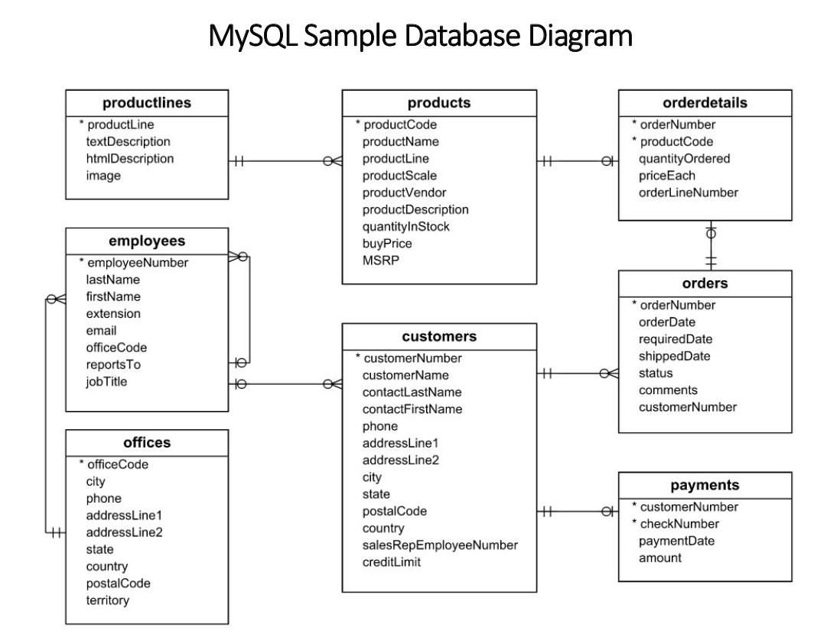

Task:
- Show all the customers whose creditLimit is greater than 20000
- Show the employees who report to VP Sales.
- Find all the customers who have set their state while filling the forms and Lives in USA and credit limit is between 100000 and 200000.
- Find all the employees who report to Sales Managers of all types.
- Find the average credit limit of customers of each country.
- Find the total no. of orders for each date and customer. Show only dates with total number of orders greater than 10 for date and customer.
- Find the name of the supervisor, job title of supervisor and total no. of supervisee using subquery. (With out using Join operation)
- Find the name of the supervisor, job title of supervisor and total no. of supervisee using subquery. (With using Join operation)
- Find all customers with a credit limit greater than average credit credit limit using WITH Clause.
- Find the rank of customer. [Customer with highest credit limit have 1 rank and Customer with lowest credit limit have highest rank]. Then, find the customer with the third highest credit limit.
- Generate a report that shows total no. of employees working in each office.
- Generate a report that shows total no. of customers visited each office.
- Generate a report that shows total payment received by each office using payment tables and essential tables. The report should show the office name, state and country, along with total payments made.
- Generate a report that shows total sales(in amount) by each office using order details table and other essential tables.
- Generate a report that shows total payment pending for each office.
- Find the creditLimit of each person, proportion of creditLimit of each person in each country. [Proportion of person in USA = creditLimit of that person / sum(creditLimit of all person in USA]
- Create a view showing the customer name, complete address, and their total number of orders.
- Update the country of a customer (use any one record).
- Delete all payments below 20,000.
- Add new payments manually for an existing customer.

